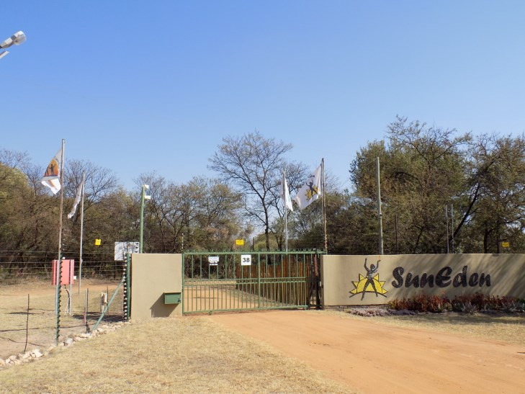
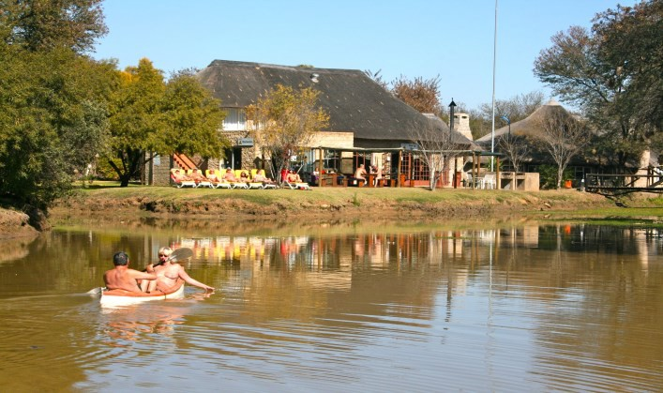
Gauteng / North West / Mpumalanga Tour.
3rd - 17th November 2023

While staying at SunEden visit Cullinan Diamond Mine and go on Safari’s in Dinokeng
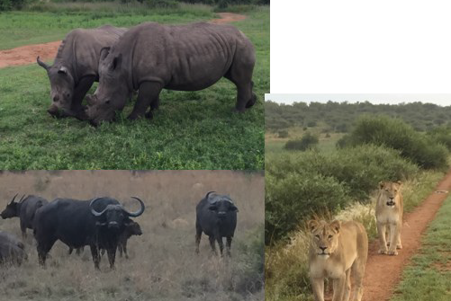
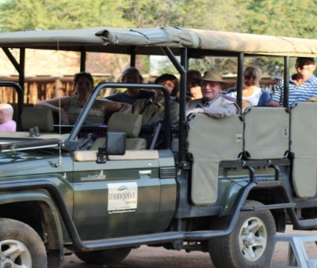
Game Reserve where you can see some of the Big 5.

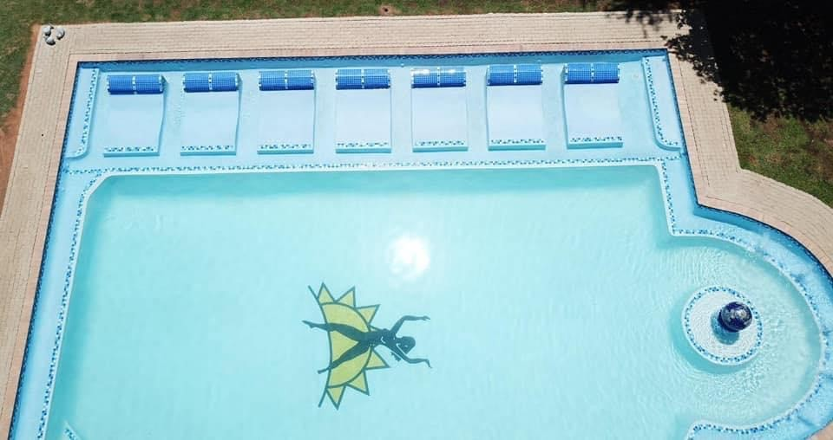

Visit Maropeng Cradle of Humankind on your way to Pilanesberg Game Reserve and Lesedi Cultural Villiage on your way back to SunEden.

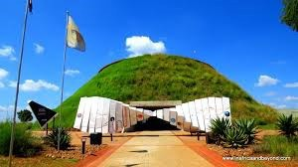
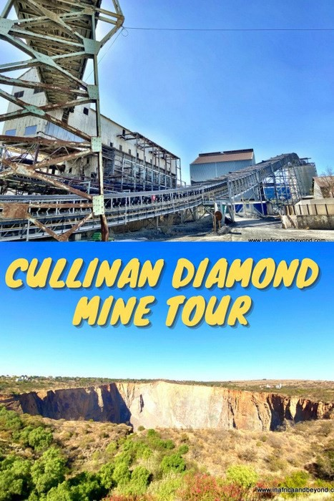
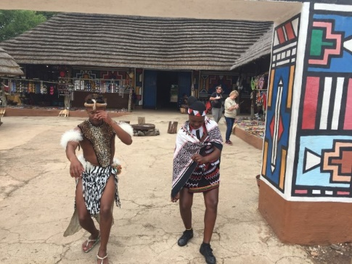
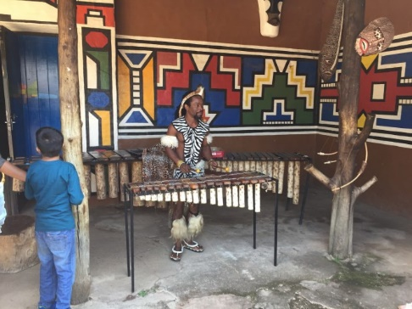
Maropeng

Cullinan Diamond Mine Surface Tour

Lesedi Cultural Village

While staying in Pilanesberg in a guest house, where you can relax naked at the pool and enjoy a South African “braai” and
go for safari’s in the morning and late afternoon.
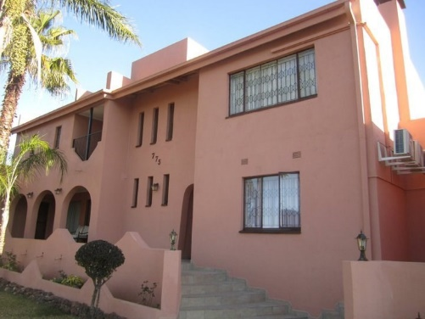
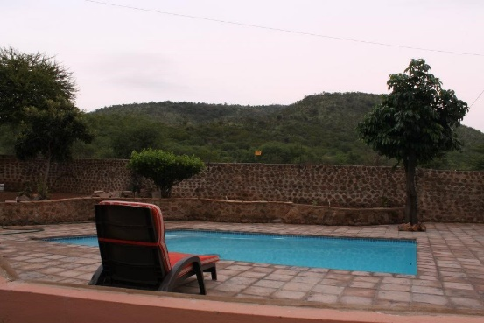
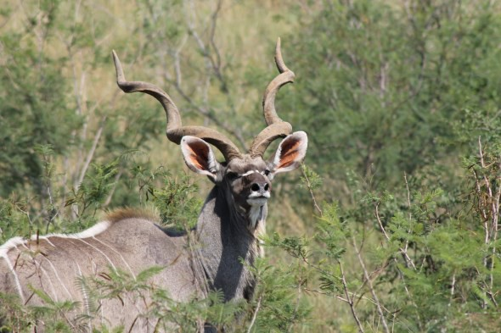
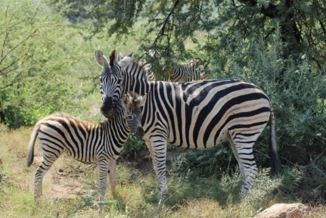
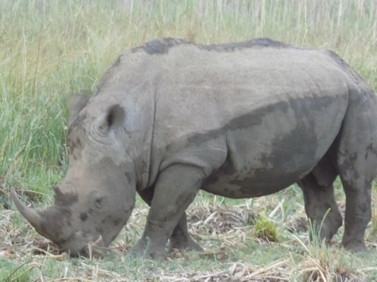
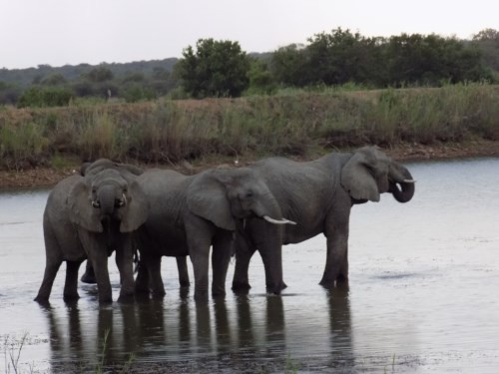

Pilanesberg

Pilanesberg

Pilanesberg

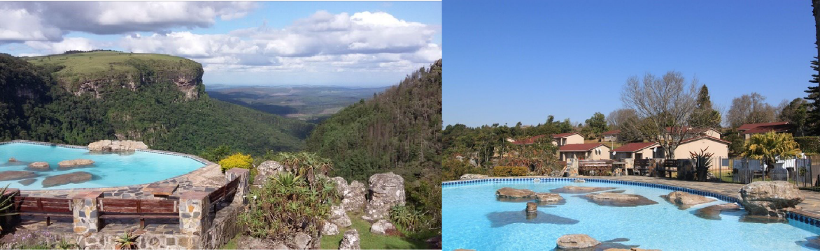
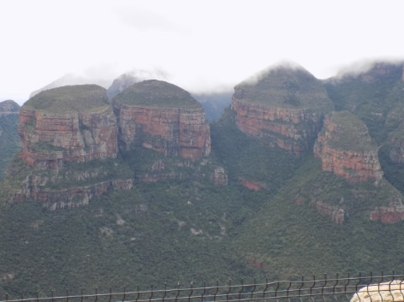
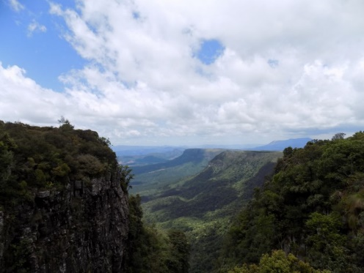
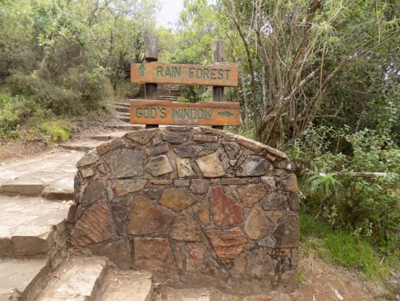
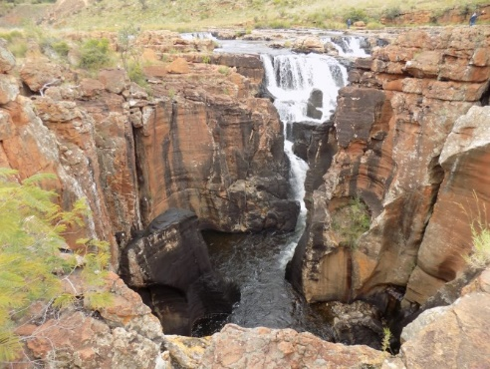
While staying in Graskop you will visit God’s Window (weather permitted), Bourke’s Luck Potholes enjoy a traditional lunch at the Boskombuis and see the famous Three Rondawels at the Blyde River Canyon and go down the Graskop Gorge in a lift..
Panorama
Three Rondawels
God’s Window

Bourke’s Luck Potholes

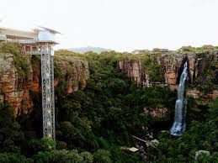
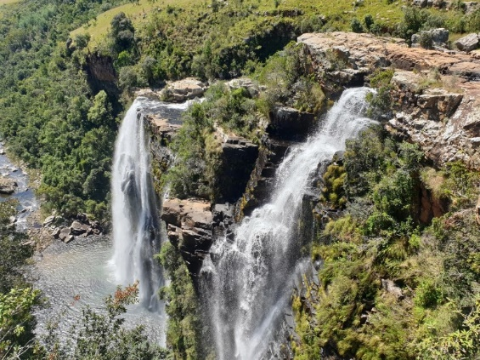
Gorge lift
Lisbon Falls

Itinerary - November 2023 Tour

Friday 3rd November 2023 - Arrive in SA - SunEden - meals dependant on flight times

Saturday 4th November 2023 - SunEden - relax at pool, breakfast, lunch and dinner

Sunday 5th November 2023 - SunEden - relax at pool, breakfast, lunch and dinner

Monday 6th November 2023 - Breakfast, lunch and dinner and afternoon Game Drive in Dinokeng

Tuesday 7th November 2023 - Leave for Pilanesberg, Breakfast at SE, excursions at Maropeng, Lunch on route and drive to Pilanesberg, supper at Pilanesberg

Wednesday 8th November 2023 - Pilanesberg - Coffee and Rusks, Game Drive, Breakfast, Lunch, another Game drive and dinner at Pilanesberg

Thursday 9th November 2023 - Leave for SunEden, Breakfast at Pilanesberg, excursion at Lesedi Cultural Village, lunch near Lesedi and dinner at SunEden

Friday 10th November 2023 - SunEden, Breakfast at SE then Cullinan Diamond Mine Surface Tour, lunch in Cullinan, dinner at SunEden

Saturday 11th November 2023 - Relax at pool, Breakfast, lunch and dinner included

Sunday 12th November 2023 - Relax at pool, breakfast, lunch and dinner included

Monday 13th November 2023 - Leave for Graskop, breakfast at SunEden, lunch and dinner at Graskop, excursion Graskop Gorge lift - Weather dependent

Tuesday 14th November 2023 - Breakfast at Graskop, lunch on route, excursions at Blyde River and Bourke’s Luck Pot Holes, Dinner at Graskop - Weather dependent

Wednesday 15th November 2023 - Breakfast at Graskop, excursions at God’s Window, Lisbon Falls, lunch and dinner at Graskop - Weather dependent

Thursday 16th November 2023 - Breakfast at Graskop, drive to SE, lunch and dinner at SunEden

Friday 17th November 2023 - Breakfast and lunch at SunEden, transport to OR Tambo International Airport

